**Microsoft Azure**

Lab Guide

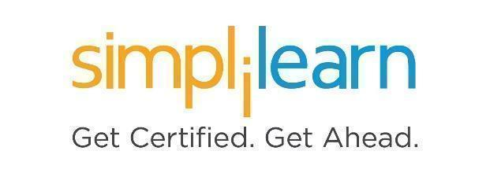

**Lab Instruction**

**Note: The screenshots used in Step 1 are only for your reference. Your LMS may look different depending on your course content.**

This section will guide you to:

* Use labs for executing all the demos included in this course

This lab has two subsections, namely:

1. Starting practice labs on LMS
2. Searching and creating the services or resources

**Step 1:** Starting **Practice Labs** on LMS

* Log in the Simplilearn LMS
* Go to the respective course

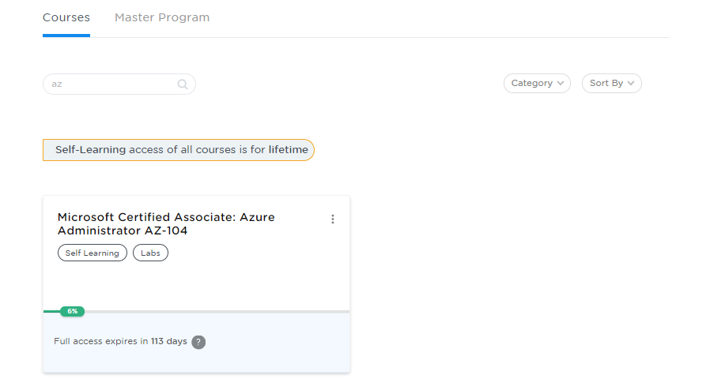

* You will see the course TOC page, click on **PRACTICE LABS**

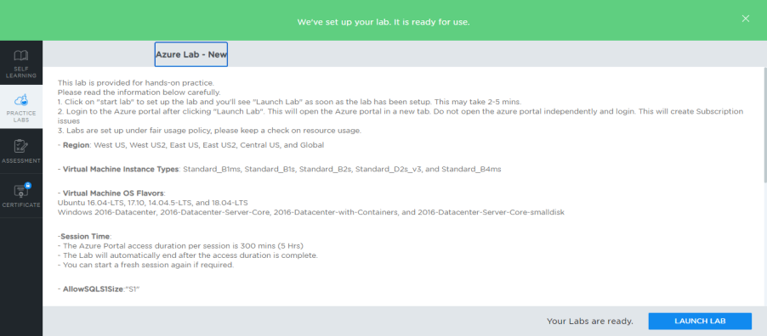

* A new window will open. Read the instructions and click on the **LAUNCH LAB** button**.** This will launch the practice labs for this course.
* In the next window, click on the **Auth URL**, which will direct you to the Azure console in a new browser tab

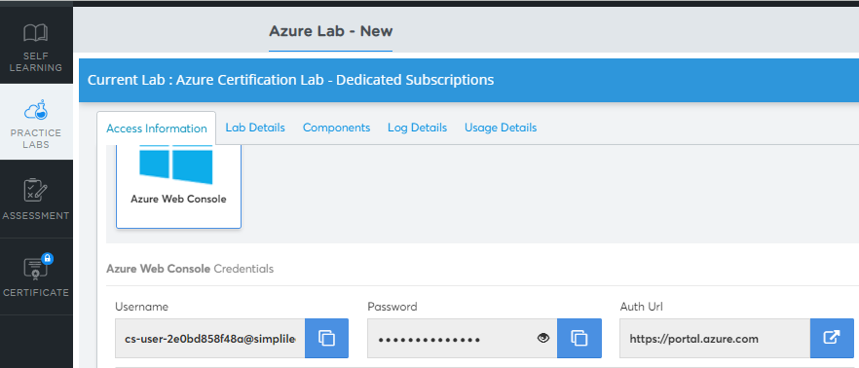

* In the newly opened tab, you need to provide the login credentials to get started. (You can copy paste the Username and password here)

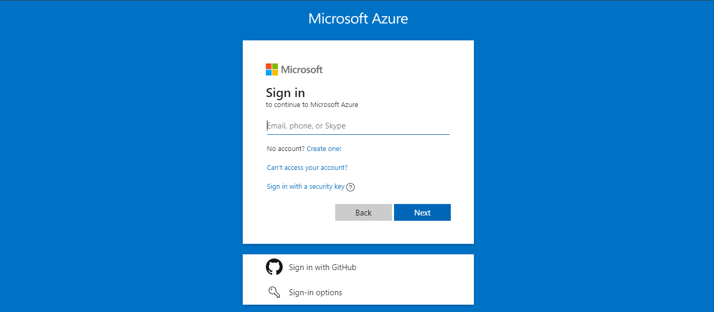

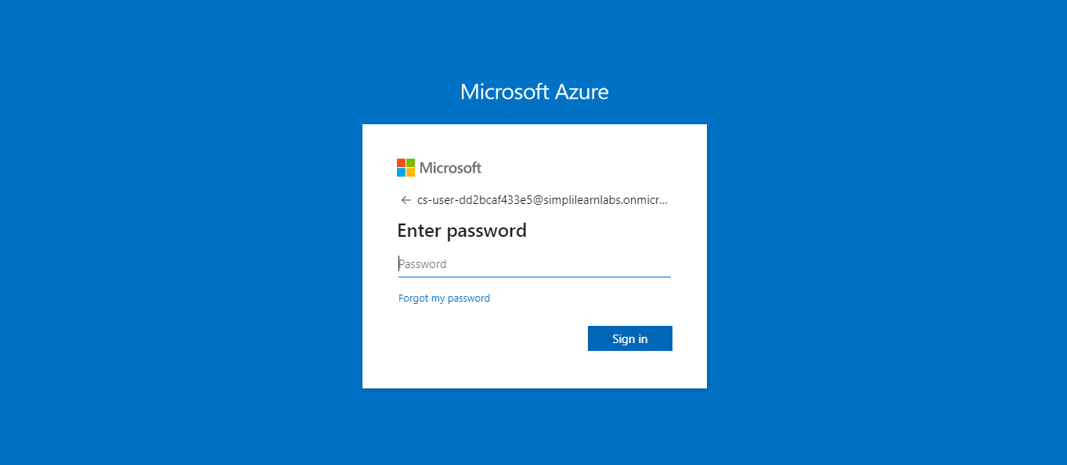

* You will be able to access the required services and resources in this console.

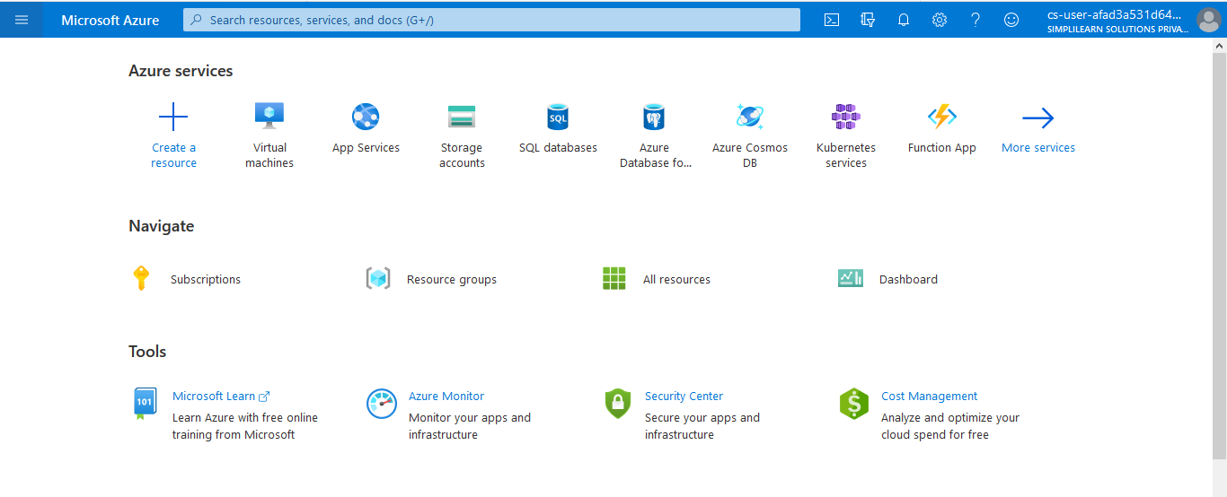

**Step 2:** Searching and creating the services or resources

* You can create services or resources by clicking on the **+** **Create a resource** option.

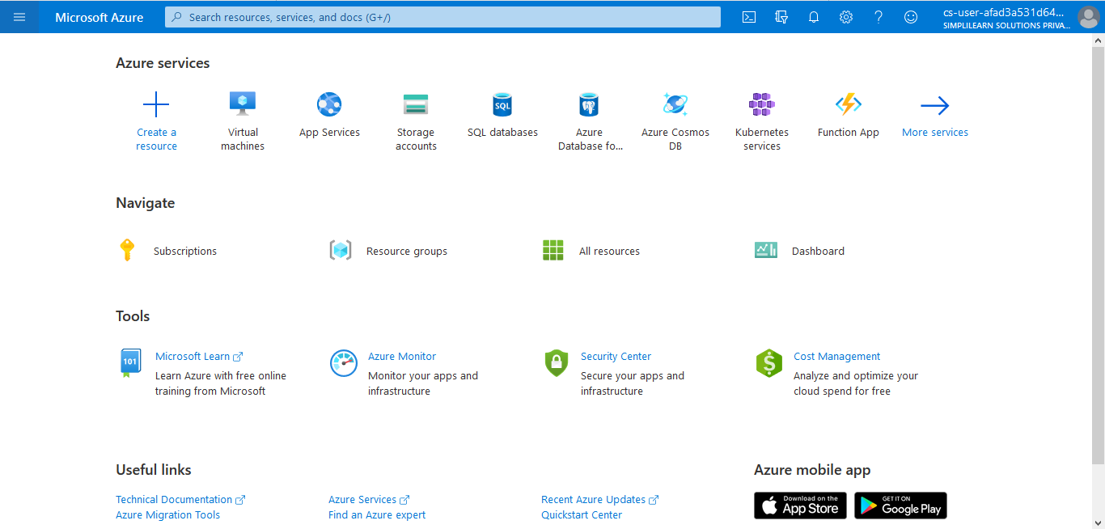

* You can search services or resources by clicking on the search tab.

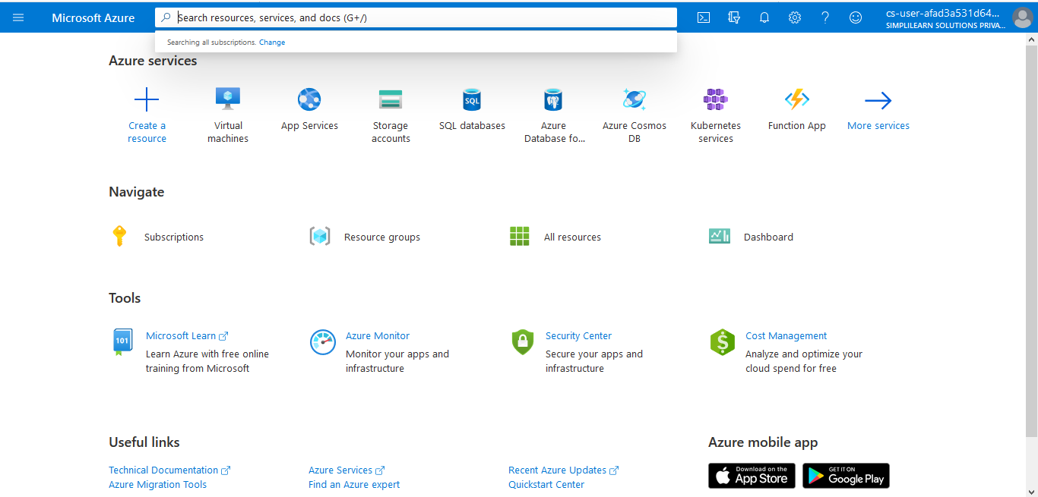

* You can create services or resources by clicking on the **+** **Create a resource** option on the left side pane.

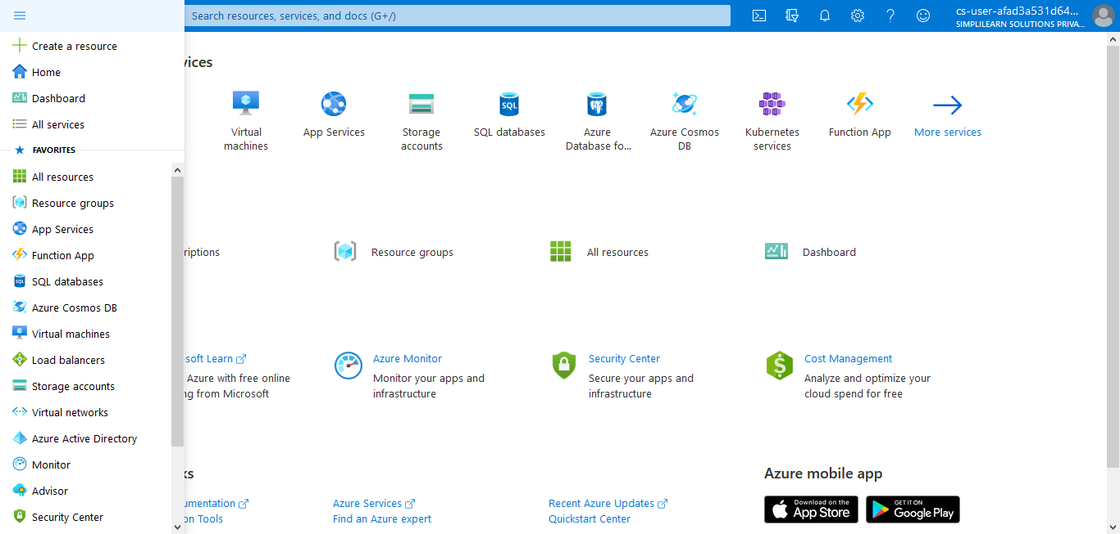

**Azure Service Guide**

**Please note: This lab is configured based on the curriculum covered during the live virtual classes.**

**Please adhere to the below configurations to avoid any error in your lab.**

**Region**: West US, West US2, East US, East US2, Central US, and Global

**Virtual Machine OS Flavors**:

Ubuntu 16.04-LTS, 17.10, 14.04.5-LTS, and 18.04-LTS

Windows 2016-Datacenter, 2016-Datacenter-Server-Core, 2016-Datacenter-with-Containers, and 2016-Datacenter-Server-Core-smalldisk

-**Application Gateway**: Tier-Standard/Size-Small

-**Load Balancer**: SKU-Basic/Assignment-Dynamic

**-Traffic Manager**: Routing method-Priority

-**AzureFileShare**: Quota-StandardFileShare/Size-PremiuimFileShare

-**StorageAccount**: ReplicationModel-LRS

-**VirtualMachineOS DiskType**: Premium SSD/Standard HDD

-**ContainerRegistry**: SKU-Basic

-**WebApp**: Publish-Code/Runtime Stack- .NET Core 3.0/OS- Windows/ SKU and Size-F1

-**Product**: State-Published/

-**CosmosDB**: API-Select Core(SQL)

-**AzureNotificationHub**: Pricing Tier-Free

-**AzureServiceBus**: Pricing Tier: Basic

-**Azure SQL DB**: Compute+Storage-Standard S1 DTU(20)

-**Microsoft.Network/loadBalancers:**  Microsoft.Network/loadBalancers/sku.name:Basic

-**Microsoft.Network/applicationGateways:**

Microsoft.Network/applicationGateways/sku.name: Standard_Small

Microsoft.Network/applicationGateways/sku.tier: Standard

Microsoft.Network/applicationGateways/sku.capacity: 2

-**Session Time**:

- The Azure Portal access duration per session is 300 mins (5 hrs)

- The Lab will automatically end after the access duration is complete.

- You can start a fresh session again if required.

- **Microsoft.Sql/servers/databases**:

Microsoft.Sql/servers/databases/requestedServiceObjectiveName: S1

Microsoft.Sql/servers/databases/sku.tier: Basic | Standard

- **AllowOnlyStandardContainerRegistry**: Microsoft.ContainerRegistry/registries/Sku.name: Basic

- **Microsoft Job collection**: Standard

- **AllowOnlyBasicPostgresql**: B_Gen5_2

- **AllowOnlyBasicMySql**:B_Gen5_2

- **Service Disabled**: Azure Marketplace, HD Insight, Azure Active Directory, IoT, Blockchain, Data Lakes, Azure Synapse, Azure Data Factory, Azure Redis Cache

**Note**: AD-specific demos are not supported in our lab at this point of time as that requires admin access. We are continuously working on them to get the services enabled for our learners to use.

**IMPORTANT:** Course-specific practices are available for download under **Course Resources**. You can refer to them to complete the demos.

